1. **Find out the mail severs of the following domain:**

* **Ibm.com**
* **Wipro.com**

Solution: open cmd

Type nslookup press enter

Type [www.ibm.com](http://www.ibm.com) press enter

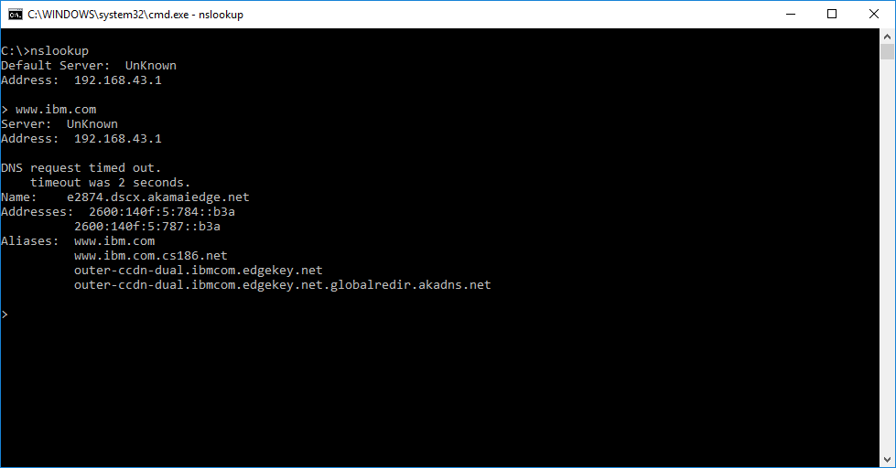

Type [www.wipro.com](http://www.wipro.com) press enter

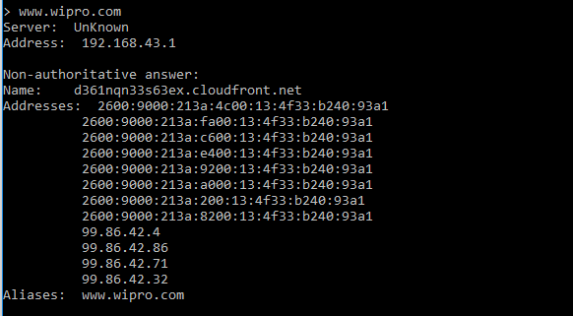

1. **Find locations, where these email server are hosted.**

Solution: type tracert ibm.com press enter

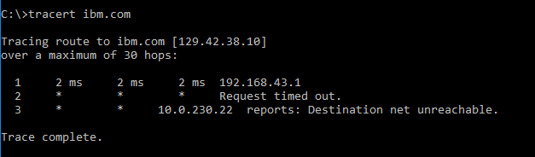

Type tracert wipro.com press enter

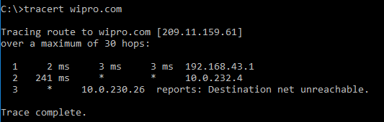

1. **Scan and find out port number open 203.163.246.23.**

Solution : open Kali

Open Terminal

Type sudo su –

Type password

Type sudo nmap 203.163.246.23

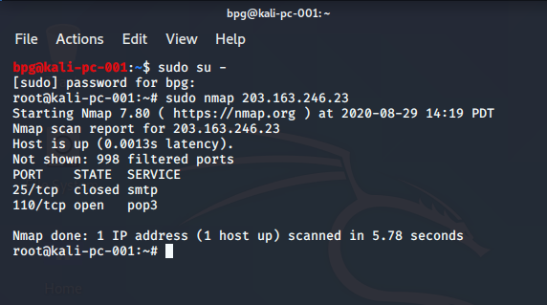

1. **Install Nessus in a VM and scan your laptop/desktop for CVE.**

Solution:

